Quick Start Guide

Getting Familiar with the 4 Main Screens in MCEBuddy 2.x

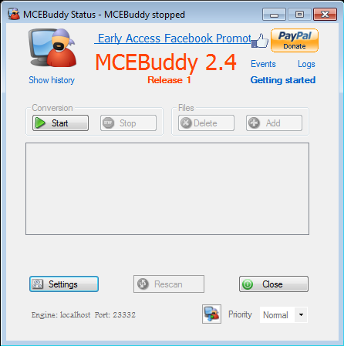
Status screen
Settings screen | 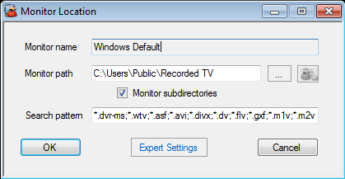  Monitor Location screen
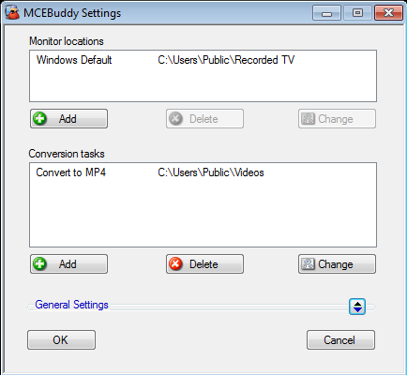 | 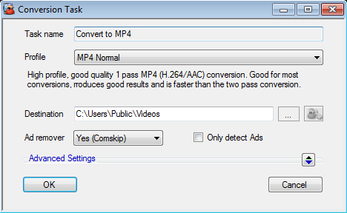  Conversion Task screen

Getting Started with MCEBuddy

Start MCEBuddy from the Window Start Menu

This will open a new window
(MCEBuddy Status)

Click on the “Settings” button

This will open a new window
(MCEBuddy Settings)

Automatic Conversions

Now we need to tell MCEBuddy the location of the video files to convert.

MCEBuddy will keep monitoring this location for new video files every few minutes and will convert it automatically whenever it finds one.

- Double click on “Windows Default”

This will open a new window
(Monitor Location)

- Click on the “...” button and select the location where MCEBuddy will look for new videos

- Click on the “OK” button

Removing Commercials and Specifying Destination Location

Now we need to tell MCEBuddy the location where to put the converted files and whether it should remove commercials while converting the video.

- Double click on “Convert to MP4”

This will open a new window
(Conversion Task)

- Click on the “...” button and select the location where the converted files will be placed

- Select “Yes (Comskip)” if you want MCEBuddy to remove commercials/advertisements while converting the videos.
Select “No” if you want to keep the commercials in the converted videos.

- Click on the “OK” button

Running MCEBuddy

You’re back to the “MCEBuddy Settings” page.

- Click on the “OK” button

Now you are back at the “MCEBuddy Status” screen.

Click on the “Start” button

If you would like to convert a file right away, simply drag and drop to the middle of the window.

You’re All Set!  If you have any files in the “Monitor Locations” folder, they should start converting automatically  You can pause conversions by clicking the “Pause” button and resume again by clicking the “Resume” button. You can stop conversions by clicking the “Stop” button and start again by clicking the “Start” button  This box shows a list of all the files in queue to be converted. Right Click on the file for more options.  You can add/delete files to be converted manually using these buttons  This bar shows the current progress/activity of the file being converted  Click on the “Close” button to close this window  MCEBuddy will continue its conversions in the background even after the window is closed.  You can always click on MCEBuddy from the Windows Start Menu to return to the “MCEBuddy Status” window to check on the status of the conversions. | 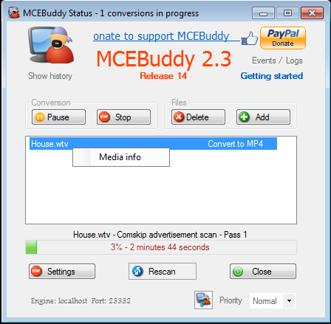  Click here to connect to a MCEBuddy engine on a different computer

Advanced Settings

REMEMBER: You can ALWAYS rest your mouse over ANY Text, Button or CheckBox to get INSTANT POP-UP help on the item.

Refer to the Wiki (https://mcebuddy2x.codeplex.com/documentation) for more details.

Click on the “Add” button under “Monitor locations” to add more locations of video files for MCEBuddy to monitor for automatic conversions.  Right click on a task to enable or disable a task.  Click on the “Add” button under “Conversion tasks” to add additional conversion tasks. For each conversion task MCEBuddy will process the video file in the queue.  e.g. – If there are 2 conversions tasks, MCEBuddy will create 2 converted files for each file in the queue.  Click to open the “General Settings” section  Delete the original video after a successful conversion  Time to wait before converting a video  Move the original video to the MCEBuddyArchive folder after a successful conversion  When source file is deleted, converted files are also deleted  You can use these to schedule conversions  Send an eMail after a successful/unsuccessful conversion  MCEBuddy can do more than one conversion simultaneously | 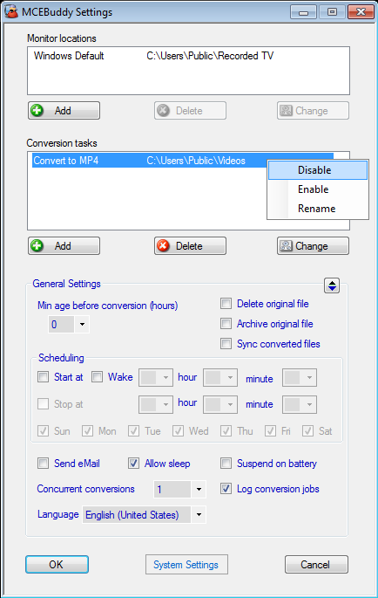  MCEBuddy Settings
Logs can help to isolate problems with conversions. The logs folder can be opened by clicking on the “Logs” text on the top right corner of the “MCEBuddy Status” window

Change the language for MCEBuddy
 | Conversion Tasks
Enter a unique name here to identify the task  Select the base profile used to convert the videos. You can create/customize these profiles  Use this button to enter the username/password if the output is a network drive  Click to open the “Advanced Settings” section  Adding converted file to libraries  Converted file renaming options. Use this to create custom file names  Convert videos who’s filenames matches this pattern  Convert videos who’s Showname/Title matches this pattern  Convert videos who’s recording Channel matches this pattern  Convert videos of this type  Maximum width of converted video  Increase or decrease Quality of the converted video  Automatically detect and optimize video conversion quality (deinterlacing, telecine etc)  Increase or decrease the audio volume of the converted video  If a video has multiple audio tracks select the audio track language or enter the 3 digit language code.  Right click on the file in the queue on the “MCEBuddy Status” page to get the audio language details and codes (Refer to Getting Video Properties below) | 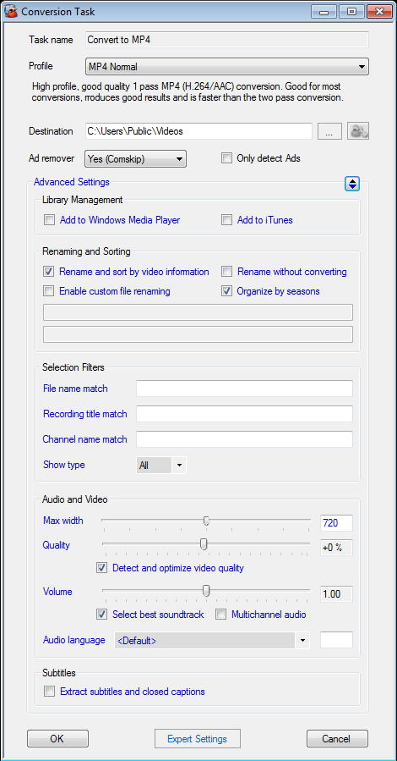  Only rename and move the file without converting  Create folders for each Season  Save the Ad locations in an EDL file instead of cutting out the Ad’s from the video  More advanced settings around metadata, banners, subtitles, chapters, embedding, trimming, queue ordering, cropping, audio sync, cropping, TiVO MAK, task management, custom Comskip INI’s etc  Extract the Closed Captions into a SRT file  Allow converted video to have multi-channel (5.1) audio. Default is stereo
Configuring eMail Notifications

You configure MCEBuddy to send eMails at different stages of the conversions (start, failed, successful, cancelled etc)

Click to open the “General Settings” section

Click “Send eMail” to being up eMail settings

This will bring up the eMail settings (SMTP) window.  Enter the server name, port, SSL, username, password, from and to eMail addresses.  You can enter multiple To eMail addresses each separated by a ;  Select the events on which you want MCEBuddy to send an eMail  Click the “Test” button to test the settings | 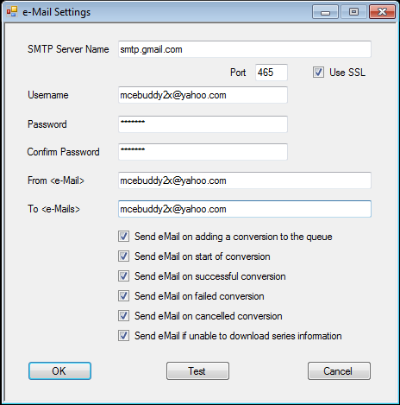

Getting Video Properties

Right click on the file in queue on the “MCEBuddy Status” window and click on Media Info to get video properties
This will pop up a window that shows the Audio/Video Information for that file.  Each file will have a Video and may have multiple Audio languages  Video Properties  Audio Language  This used while selecting the Audio Language in the “Conversion tasks” window  Language code (3 digit)  This used while selecting the Audio Language in the “Conversion tasks” window | 