Configure MCEBuddy to Accept Remote Connections

Start MCEBuddy from the Window Start Menu (on the machine where MCEBuddy is running)  This will open a new window  (MCEBuddy Status)  Click on the “Settings” button | 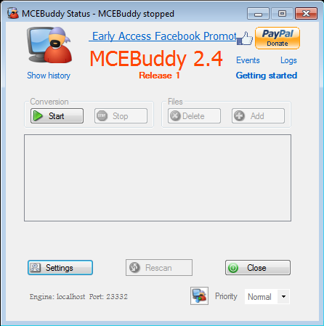

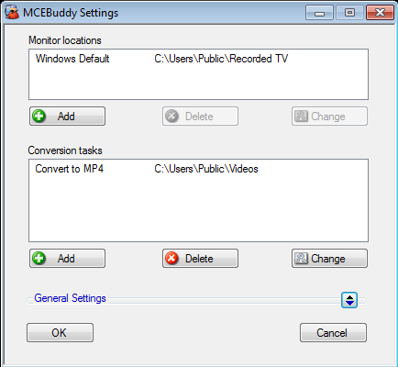
This will open a new window
(MCEBuddy Settings)

Click on the “General Settings” button to expand the section

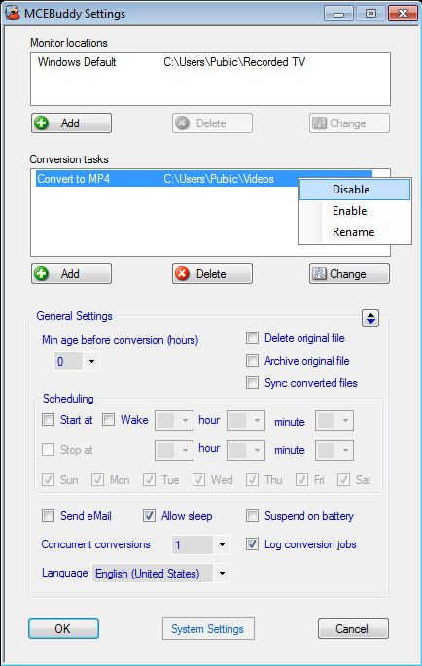
This will expand the General Settings section
Click on the “System Settings” button

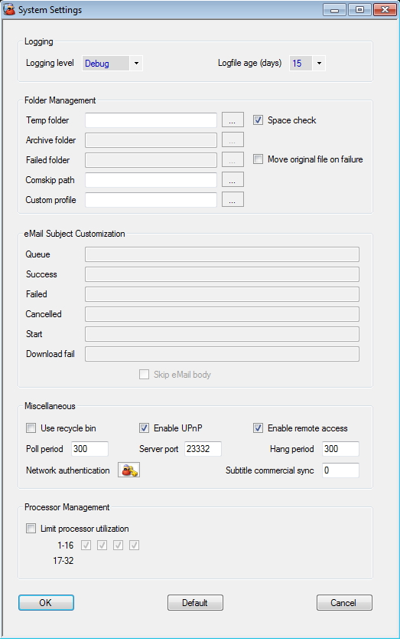
This will open a new window (System Settings)

Check the “Enable UPnP” box if you are connecting from behind a Home Gateway or Router (e.g. from the Internet)
Check the “Enable Remote Access” box
Click on the “OK” button
You’re back to the (MCEBuddy Settings) page.

Click on the “OK” button

Connecting the MCEBuddy Remote Client
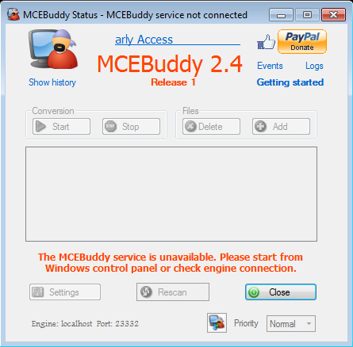
Start MCEBuddy Remote Client from the Windows Start Menu on the remote machine

This will open a new window
(MCEBuddy Status)

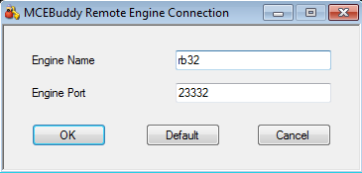
Click on the “OK” button

Enter the Name or IP Address of the computer where the MCEBuddy Engine is running

e.g. rb32 or 192.168.1.34
Click on this “Icon” to enter the details of the MCEBuddy Engine you want to connect to.

This will open a new window
(MCEBuddy Remote Engine Connection)

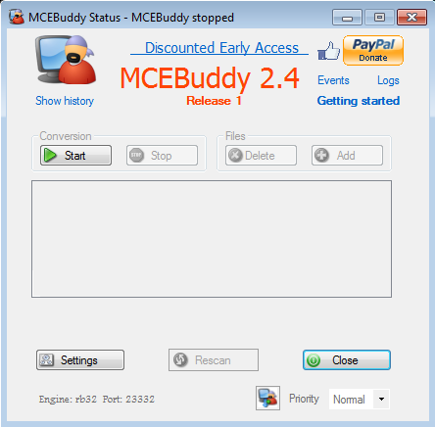
This shows the Name and Port number of the MCEBuddy Engine the Remote Client is trying/is connected to
You’re All Set!

If you have any files in the “Monitor Locations” folder, they should start converting automatically

